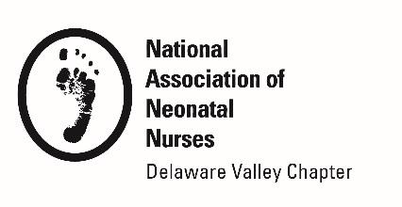

DVANN PROFESSIONAL DEVELOPMENT

AWARD APPLICATION

Purpose: To recognize and encourage professional development in neonatal nursing.

Requirements: To be eligible for this award, you must be a DVANN member and meet one of the following criteria during 2022: (Choose one)

□ Eligible to sit for a certification exam in neonatal nursing or related field □ Enrolled in an accredited college or university pursuing an undergraduate or graduate degree in nursing

Selection Criteria: The applicant will demonstrate contributions to the profession of neonatal nursing in the following ways:
- Maintains practice in neonatal nursing
- Attends DVANN meetings
- Promotes DVANN's mission and goals

Award Recognition:
- $500 award
- A complimentary DVANN conference registration
- Recognition in Preemie Press

Deadline and Submissions:
Please complete application form and submit all required material to
info@dvann.org

Deadline for application: November 10, 2022

Applicant Information: Date: ________________

Name/Credentials ______________________________________________

Job Title ______________________________________________________

Mailing Address_________________________________________________

Phone______________________________________________

Email______________________________________________

DVANN PROFESSIONAL DEVELOPMENT AWARD APPLICATION

Answer the following questions.
Attach a separate sheet of paper if necessary.

DVANN’s mission is to promote the highest standards of evidenced-based neonatal nursing practice and education, to enhance professional development in neonatal nursing, and to support families and community.

- How you are working to promote and/or demonstrate DVANN’s mission in your nursing practice?

- Describe your current involvement in neonatal nursing.

- Describe your participation in the Delaware Valley Association of Neonatal Nurses.

- How do you plan to use this award?

